Mining( Twitter & Facebook ) Code:-Reports:-Graphs

R Code: - Analyze Stock Market of Apple by latest 6 months.

1. # install quantmod

2.
3. if (!require("quantmod")) {

4. install.packages("quantmod")
5. library(quantmod)

6. }
7.

8. # Date between stock price needed to analyse
9. start <- as.Date("2018-06-01")

10. end <- as.Date("2018-12-26")
11. #Link with yahoo money

12. getSymbols("AAPL", src = "yahoo", from = start, to = end)
13. class(AAPL)

14. head(AAPL)
15. #ploat1

16. plot(AAPL[, "AAPL.Close"], main = "AAPL")
17. #plot2
18. candleChart(AAPL, up.col = "black", dn.col = "red", theme = "white", subset = "2018-01-
26/")
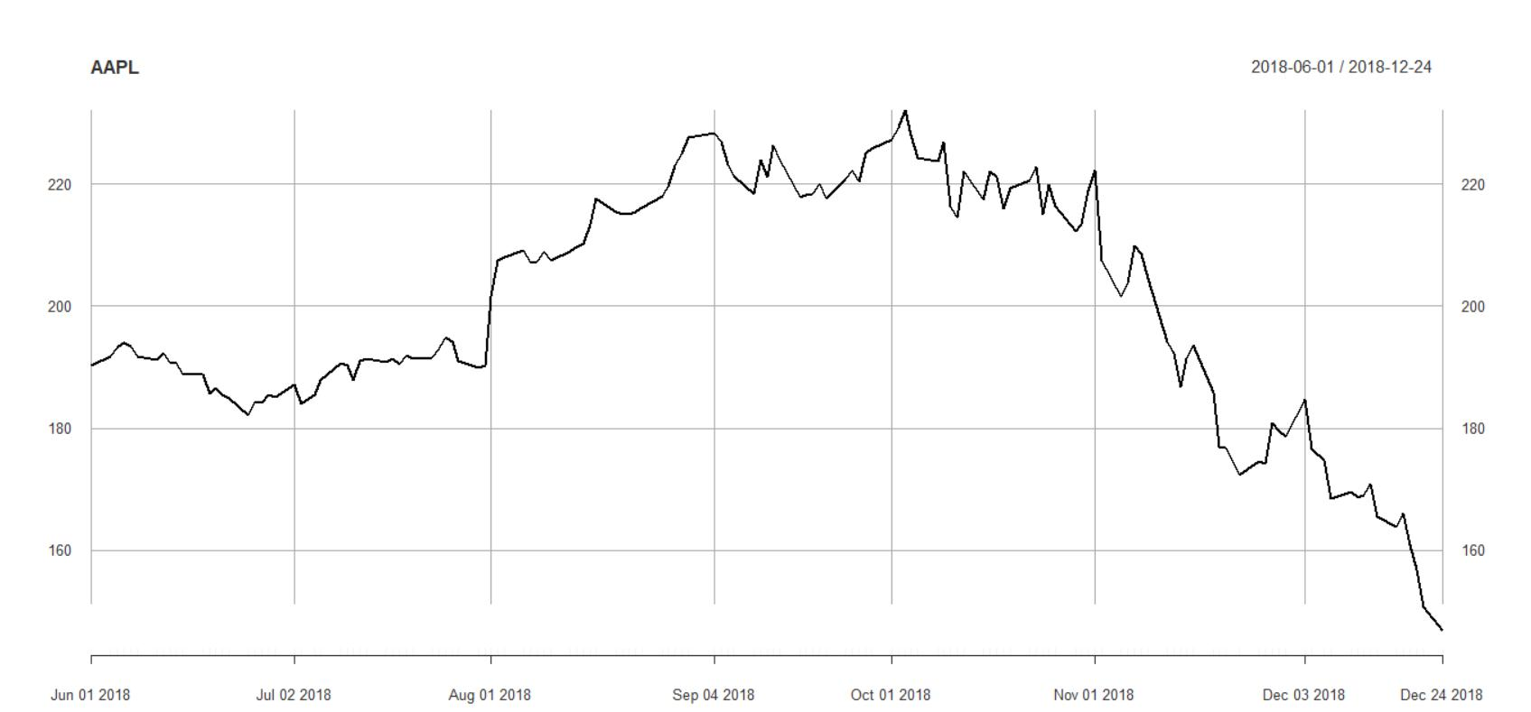
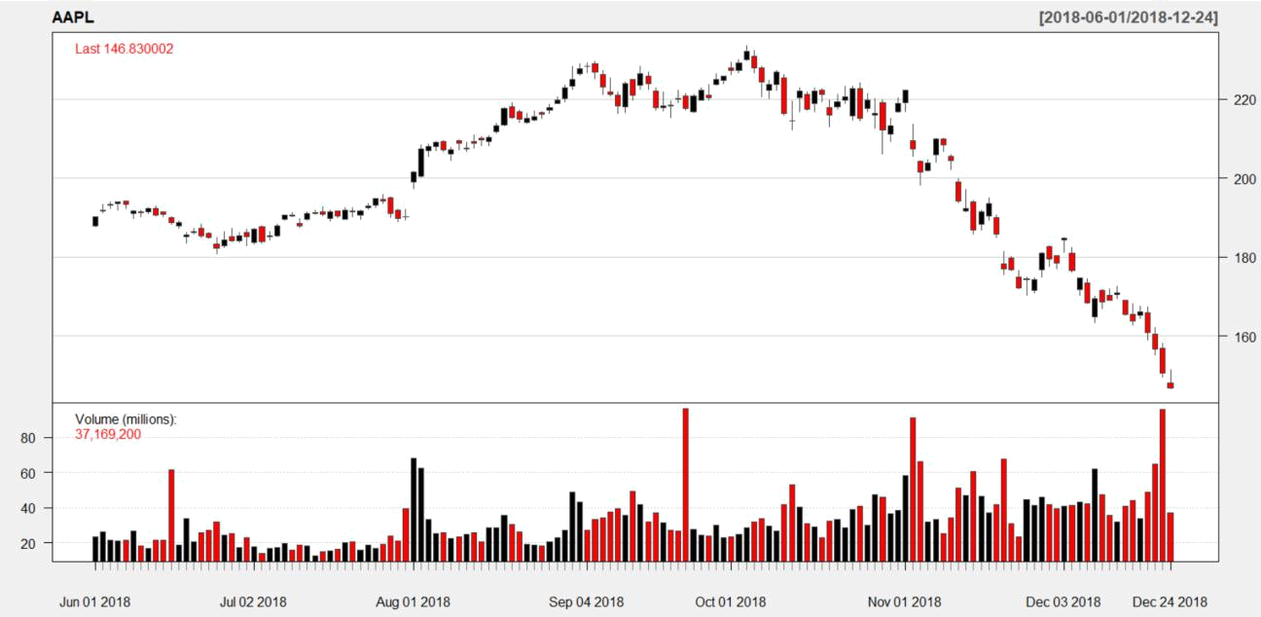

Python code for Twitter Tweets collection.

1. ### Collecting required data from twitter to csv file
2.
3. import tweepy

4. import csv
5. import pandas as pd

6.
7. ### credentials

8.
9. consumer_key = "afssjfhsfhsfhs"

10. consumer_secret = "slkfslklaskjalkjflkf"
11. access_token = "flkasflsakfjsalkfjalfjaslkfjlks"

12. access_token_secret = "dskflakdsf;dsfj;lskfjlf;sfjklfj"
13.

14.
15.

16. auth = tweepy.OAuthHandler(consumer_key, consumer_secret)
17. auth.set_access_token(access_token, access_token_secret)

18. api = tweepy.API(auth,wait_on_rate_limit=True)
19.

20. csvFile = open('Twitter_Apple_S1.csv', 'a',encoding="utf-8", newline='')
21. csvWriter = csv.writer(csvFile)

22.
23. csvWriter.writerow(['Id','Name','Nick Name','Country','Date','Tweet','Favs','Retweets']
)

24. for tweet in tweepy.Cursor(api.search,q="#apple",count=100,

25. | lang="en",
26. | since="2018-12-26").items():
27.

28. print (tweet.id,tweet.user.name,tweet.user.screen_name, tweet.user.location,twe
et.created_at,tweet.text,tweet.favorite_count,tweet.retweet_count,)
29. csvWriter.writerow([tweet.id,tweet.user.name,tweet.user.screen_name,tweet.user.
location,tweet.created_at, tweet.text.encode('utf-
8'),tweet.favorite_count,tweet.retweet_count])

30.
31.

32.
33. # Converting .CSV file to Excel Work book as for next analysis

34.
35. import os

36. import glob
37. import csv

38. from xlsxwriter.workbook import Workbook
39.

40.
41. for csvfile in glob.glob(os.path.join('.', 'Twitter_Apple_S1.csv')):

42. workbook = Workbook(csvfile[:-4] + 'Twitter_Apple_S1.xlsx')
43. worksheet = workbook.add_worksheet()

44. with open(csvfile, 'rt', encoding='utf8') as f:
45. reader = csv.reader(f)

46. for r, row in enumerate(reader):
47. for c, col in enumerate(row):

48. worksheet.write(r, c, col)
49. workbook.close()

Code for Sentiment analysis.

1. # Importing all desired packages
2.
3.

4. import pandas as pd
5. import string

6. import re
7. import emoji

8. import nltk
9. from nltk.corpus import stopwords

10. from nltk.tokenize import word_tokenize
11. from collections import Counter

12. from bs4 import BeautifulSoup
13. from textblob import TextBlob

14.
15.

16. # removing null values from colums
17. def filter_group_remove_null_columns(data_frame, filter_column_list=None, result_column
_list=None,group_by_column_list=None):

18. if filter_column_list is None:
19. filter_column_list = []

20.
21. if group_by_column_list is None:

22. if result_column_list is None:
23. return data_frame.dropna(subset=filter_column_list)

24. else:
25. return (data_frame.dropna(subset=filter_column_list))[result_column_list]
26. else:
27. return (data_frame.dropna(subset=filter_column_list)).groupby(group_by_column_l
ist)[group_by_column_list]
28.
29. | # lookup f emoji from tweet text
30.
31. def handle_iconic_emojis(tweet):
32. | tweet | = emoji.demojize(tweet)
33. | # Smile
34. | tweet | = re.sub(r'(:smiling_face_with_smiling_eyes:)', ' smile ', tweet)
35. | tweet | = re.sub(r'(:smiling_face_with_sunglasses:)', ' smile ', tweet)
36. | tweet | = re.sub(r'(:smiling_face:)', ' smile ', tweet)
37. | tweet | = re.sub(r'(:slightly_smiling_face:)', ' smile ', tweet)
38. | tweet | = re.sub(r'(:slightly_smiling_face:)', ' smile ', tweet)
39. | tweet | = re.sub(r'(:hugging_face:)', ' smile ', tweet)
40. | tweet | = re.sub(r'(:star-struck:)', ' smile ', tweet)
41. | # Laugh
42. | tweet | = re.sub(r'(:face_with_tears_of_joy:)', ' laugh ', tweet)
43. | tweet | = re.sub(r'(:grinning_face:)', ' laugh ', tweet)
44. | tweet | = re.sub(r'(:grinning_face_with_big_eyes:)', ' laugh ', tweet)
45. | tweet | = re.sub(r'(:beaming_face_with_smiling_eyes:)', ' laugh ', tweet)
46. | tweet | = re.sub(r'(:rolling_on_the_floor_laughing:)', ' laugh ', tweet)
47. | tweet | = re.sub(r'(:grinning_face_with_smiling_eyes:)', ' laugh ', tweet)
48. | tweet | = re.sub(r'(:grinning_face_with_sweat:)', ' laugh ', tweet)
49. | tweet | = re.sub(r'(:grinning_squinting_face:)', ' laugh ', tweet)
50. | # Love
51. | tweet | = re.sub(r'(:red_heart:)', ' love ', tweet)
52. | tweet | = re.sub(r'(:kiss_mark:)', ' love ', tweet)
53. | tweet | = re.sub(r'(:smiling_face_with_heart-eyes:)', ' love ', tweet)
54. | tweet | = re.sub(r'(:face_blowing_a_kiss:)', ' love ', tweet)
55. | # Wink
56. | tweet | = re.sub(r'(:winking_face:)', ' wink ', tweet)
57. | tweet | = re.sub(r'(:winking_face_with_tongue:)', ' wink ', tweet)
58. | # Sad
59. | tweet | = re.sub(r'(:unamused_face:)', ' sad ', tweet)
60. | tweet | = re.sub(r'(:downcast_face_with_sweat:)', ' sad ', tweet)
61. | tweet | = re.sub(r'(:pensive_face:)', ' sad ', tweet)
62. | tweet | = re.sub(r'(:confused_face:)', ' sad ', tweet)
63. | tweet | = re.sub(r'(:frowning_face:)', ' sad ', tweet)
64. | tweet | = re.sub(r'(:slightly_frowning_face:)', ' sad ', tweet)
65. | tweet | = re.sub(r'(:confounded_face:)', ' sad ', tweet)
66. | tweet | = re.sub(r'(:disappointed_face:)', ' sad ', tweet)
67. | # Cry
68. | tweet | = re.sub(r'(:sleepy_face:)', ' cry ', tweet)
69. | tweet | = re.sub(r'(:tired_face:)', ' cry ', tweet)
70. | tweet | = re.sub(r'(:crying_face:)', ' cry ', tweet)
71. | tweet | = re.sub(r'(:loudly_crying_face:)', ' cry ', tweet)
72. | tweet | = re.sub(r'(:anxious_face_with_sweat:)', ' cry ', tweet)
73.
74. | return emoji.emojize(tweet)
75.
76. | # handle text emojis
77. def handle_text_emojis(tweet):
78. | # Smile -- :), : ), :-), (:, ( :, (-:, :')
79. | tweet | = re.sub(r'(:\s?\)|:-\)|\(\s?:|\(-:|:\'\))', ' smile ', tweet)
80. | # Laugh -- :D, : D, :-D, xD, x-D, XD, X-D
81. | tweet | = re.sub(r'(:\s?D|:-D|x-?D|X-?D)', ' laught ', tweet)
82. | # Love -- <3, :*
83. | tweet | = re.sub(r'(<3|:\*)', ' love ', tweet)
84. | # Wink -- ;-), ;), ;-D, ;D, (;, (-;
85. | tweet | = re.sub(r'(;-?\)|;-?D|\(-?;)', ' wink ', tweet)
86. | # Sad | -- :-(, : (, :(, ):, )-:
87. | tweet | = re.sub(r'(:\s?\(|:-\(|\)\s?:|\)-:)', ' sad ', tweet)
88. | # Cry | -- :,(, :'(, :"(

89. tweet = re.sub(r'(:,\(|:\'\(|:"\()', ' cry ', tweet)
90. return tweet
91.

92. # Differentiate colums
93. def prepare_massive_numeric_data_to_view(data_frame, column_name, threshold=0):

94. | total = (data_frame.sum()[column_name])
95. | desired_rows = data_frame[data_frame[column_name] > (total * threshold)]
96. | undesired_rows = data_frame[data_frame[column_name] <= (total * threshold)]
97. | if undesired_rows.sum()[column_name] > 0:
98. | desired_rows.loc['Other'] = undesired_rows.sum()[column_name]
99. | return desired_rows
100.
101.
102. | #Preparing for cleaned data, regex,hashtag,urls etc
103.
104. | def get_cleaned_data(tweets):
105. | processed_tweets_text = []
106. | for tweet_id, tweet in enumerate(tweets):
107. | # HTML decoding
108. | tweet = BeautifulSoup(tweet, 'lxml').getText()
109.
110. | # Remove mentions
111. | tweet = re.sub(r'@[A-Za-z0-9]+', '', tweet)
112.
113. | # Remove URL links
114. | tweet = re.sub(r'https?://[A-Za-z0-9./]+', '', tweet)
115.
116. | # Replace emojies (Iconic or text)
117. | tweet = handle_text_emojis(tweet)
118. | tweet = handle_iconic_emojis(tweet)
119.
120. | # # Remove hashtags, numbers, extra signs and etc
121. | tweet = re.sub('[^a-zA-Z]', ' ', tweet)
122.
123. | # Convert more than 2 letter repetitions to 2 letter (funnnnny --
> funny)
124. | tweet = re.sub(r'(.)\1+', r'\1\1', tweet)
125.
126. | # Convert to lowercase
127. | tweet = tweet.lower()
128.
129. | processed_tweets_text.append(tweet)
130.
131. | return processed_tweets_text
132.
133. | # Most common words in tweet
134. | def get_most_common_words(tweets, top_words_number=0, key_list=None):
135. | if key_list is None:
136. | key_list = []
137. | punctuation = list(string.punctuation)
138. | stop = stopwords.words('english') + punctuation + ['rt', 'via']
139.
140. | count_all = Counter()
141.
142. | for tweet in tweets:
143. | word_all = []
144. | for word in tweet.split(' '):
145. | if word not in stop:
146. | word_all.append(word)
147. | count_all.update(word_all)
148.

149. | if top_words_number > 0:
150. | dic = {'most_common': count_all.most_common(top_words_number)}
151. | else:
152. | dic = {}
153. | for key in key_list:
154. | dic.update({key: count_all[key]})
155.
156. | return dic
157.
158. | #Anayzing sentiment TextBlob data
159. | def analyze_sentiment(tweet):
160. | analysis = TextBlob(tweet)
161. | if analysis.sentiment.polarity > 0:
162. | return 1
163. | elif analysis.sentiment.polarity == 0:
164. | return 0
165. | else:
166. | return -1
167. | #process sentiment
168. | def get_sentiments_data(tweets):
169. | processed_tweets_sentiment = []
170. | for tweet in tweets:
171. | processed_tweets_sentiment.append(analyze_sentiment(tweet))
172. | return processed_tweets_sentiment
173. | # Get Count Summary
174. | def get_sentiment_count_summary(tweets):
175. | pos_tweets = 0
176. | neu_tweets = 0
177. | neg_tweets = 0
178. | for tweet in tweets:
179. | tweets_sentiment = analyze_sentiment(tweet)
180. | if tweets_sentiment == 1:
181. | pos_tweets += 1
182. | elif tweets_sentiment == 0:
183. | neu_tweets += 1
184. | else:
185. | neg_tweets += 1
186.
187. | return {
188. | 'Positive': pos_tweets,
189. | 'Neutral': neu_tweets,
190. | 'Negative': neg_tweets,
191. | }
192. | # Percentage summary
193. | def get_sentiment_percentage_summary(tweets):
194. | tweets_sentiment_count = get_sentiment_count_summary(tweets)
195.
196. | return {
197. | 'Positive': (tweets_sentiment_count['Positive'] * 100) / len(tweets),
198. | 'Neutral': (tweets_sentiment_count['Neutral'] * 100) / len(tweets),
199. | 'Negative': (tweets_sentiment_count['Negative'] * 100) / len(tweets),
200. | }
201.
202. | # Path of collected tweets stored in Xlsx
203. | file ="C:\\Users\\mrikumar\\Desktop\\Twitter\\Final_code_to_Submit\\Twitter_Appl
e_S1.xlsx"
204.
205. | xl=pd.ExcelFile(file)
206. | data_frame_from_excel = xl.parse(xl.sheet_names[0])
207. | cleaned_tweets = get_cleaned_data(data_frame_from_excel['Tweet'])
208. | data_frame_from_excel['Tweet'] = cleaned_tweets

209. | data_frame_from_excel.to_csv('cleaned_dataset.csv')
210.
211.
212. | #Function for plotting bar chart
213. | def plot_bar_x(data_frame, column_name, title, x_label, y_label):
214. | import matplotlib.pyplot as plt
215. | from matplotlib.ticker import MaxNLocator
216.
217. | ax = data_frame.plot(kind='bar', title=title, figsize=(len(data_frame[column
_name]) * 3 + 3, 10), legend=True,
218. | fontsize=12)
219. | ax.set_xlabel(x_label, fontsize=12)
220. | ax.set_ylabel(y_label, fontsize=12)
221. | ax.yaxis.set_major_locator(MaxNLocator(integer=True))
222. | plt.savefig(title)
223.
224. | #Function for plotting pie chart
225.
226. | def plot_pie_x(data_frame, labels_list, y_column_name, title):
227. | import matplotlib.pyplot as plt
228.
229. | plt.figure(figsize=(14, 6))
230. | ax1 = plt.subplot(121, aspect='equal')
231. | data_frame.plot(kind='pie', y=y_column_name, ax=ax1, autopct='%1.1f%%', titl
e=title,
232. | startangle=90, shadow=False, labels=labels_list, legend=Fals
e, fontsize=14)
233. | plt.savefig(title)
234. | # Group tweets counts by country
235. | def Country_tweet():
236. | grouped = filter_group_remove_null_columns(
237. | data_frame_from_excel,
238. | filter_column_list=['Country'],
239. | group_by_column_list=['Country'],
240. | ).count()
241. | grouped = prepare_massive_numeric_data_to_view(grouped, 'Country', threshold
=0.01)
242. | plot_bar_x(grouped, 'Country', title='Group By Country', x_label='Countries'
, y_label='Count')
243.
244. | # determine total sentiments
245. | def Total_tweets_setniment():
246. | sentiments_value = get_sentiment_percentage_summary(cleaned_tweets)
247. | # sample for sentiment_value = {'Positive': 44.44444444444444, 'Neutral': 44
.44444444444444, 'Negative': 11.11111111111111}
248. | keys = list(sentiments_value.keys())
249. | values = list(sentiments_value.values())
250. | data_frame = pd.DataFrame(
251. | {'Sentiment': keys, 'Values': values}, columns=['Sentiment', 'Values'])
252. | plot_pie_x(data_frame, keys, 'Values', title='Total Tweets Sentiments')
253.
254. | # determine Tweets on Apple products
255. | def Tweets_on_products():
256. | products_repetition_count = get_most_common_words(
257. | tweets=cleaned_tweets,
258. | key_list=['ipod', 'ipad', 'iphone', 'mac', 'ios', 'iwatch'])
259. | keys = list(products_repetition_count.keys())
260. | values = list(products_repetition_count.values())
261. | data_frame = pd.DataFrame(
262. | {'Products': keys, 'Counts': values}, columns=['Products', 'Counts'])

263. | plot_pie_x(data_frame, keys, 'Counts', title='Group Tweets By Product')
264.
265. | # determine setimnets on each of Apple products
266. | def sentiments_on_products():
267. | products = ['ipod', 'ipad', 'iphone', 'mac', 'ios', 'iwatch']
268. | for product in set(products):
269. | selected_data_frame = data_frame_from_excel.loc[data_frame_from_excel['T
weet'].str.contains(product)]
270. | if selected_data_frame.values.size == 0:
271. | continue
272. | sentiments_value = get_sentiment_percentage_summary(selected_data_frame[
'Tweet'])
273. | keys = list(sentiments_value.keys())
274. | values = list(sentiments_value.values())
275. | data_frame = pd.DataFrame(
276. | {'Sentiment': keys, 'Values': values}, columns=['Sentiment', 'Values
'])
277. | plot_pie_x(data_frame, keys, 'Values', title='Group Tweets Sentiments Fo
r Product %s' % product)
278.
279. | # determine ReTweets on Apple products
280. | def retweet_per_products():
281. | products = ['ipod', 'ipad', 'iphone', 'mac', 'ios', 'iwatch']
282. | result_dict = {}
283. | for product in set(products):
284. | selected_data_frame = data_frame_from_excel.loc[data_frame_from_excel['T
weet'].str.contains(product)]
285. | if selected_data_frame.values.size == 0:
286. | continue
287. | result_dict.update({product: selected_data_frame.sum()['Retweets']})
288. | keys = list(result_dict.keys())
289. | values = list(result_dict.values())
290. | data_frame = pd.DataFrame(
291. | {'Products': keys, 'Values': values}, columns=['Products', 'Values'])
292. | plot_pie_x(data_frame, keys, 'Values', title='Retweets per product')
293.
294. | # determine Tweets Favorites on Apple products
295. | def Favorites_per_products():
296. | products = ['ipod', 'ipad', 'iphone', 'mac', 'ios', 'iwatch']
297. | result_dict = {}
298. | for product in set(products):
299. | selected_data_frame = data_frame_from_excel.loc[data_frame_from_excel['T
weet'].str.contains(product)]
300. | if selected_data_frame.values.size == 0:
301. | continue
302. | result_dict.update({product: selected_data_frame.sum()['Favs']})
303. | keys = list(result_dict.keys())
304. | values = list(result_dict.values())
305. | data_frame = pd.DataFrame(
306. | {'Products': keys, 'Values': values}, columns=['Products', 'Values'])
307. | plot_pie_x(data_frame, keys, 'Values', title='Favorites per product')
308.
309.
310. | # Calling all functions individually to get the desired sentiments in the form o
f plotting chart/graph
311.
312. | # Total number of tweets by country
313. | Country_tweet()
314. | # Total sentiments on collected Tweets
315. | Total_tweets_setniment()
316. | # Tweets on products Apple products

317. Tweets_on_products()
318. # Sentimets on each of Apple products
319. sentiments_on_products()

320. # ReTweets on Apple products
321. retweet_per_products()

322. # Tweets Favorites on Apple products
323. Favorites_per_products()

324.

Results/Reports: -
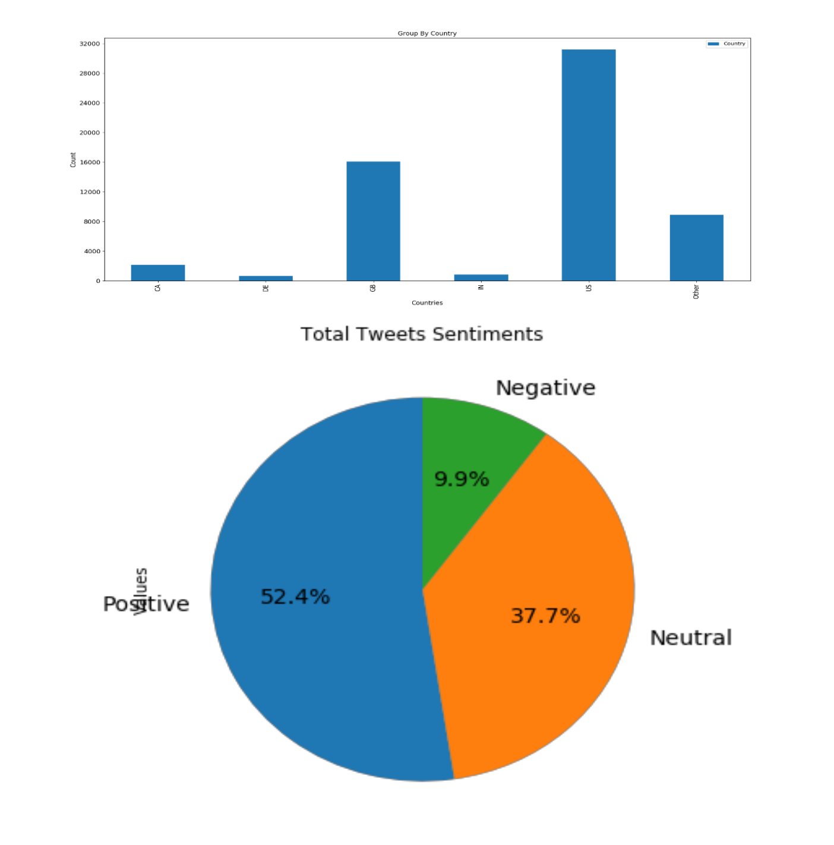
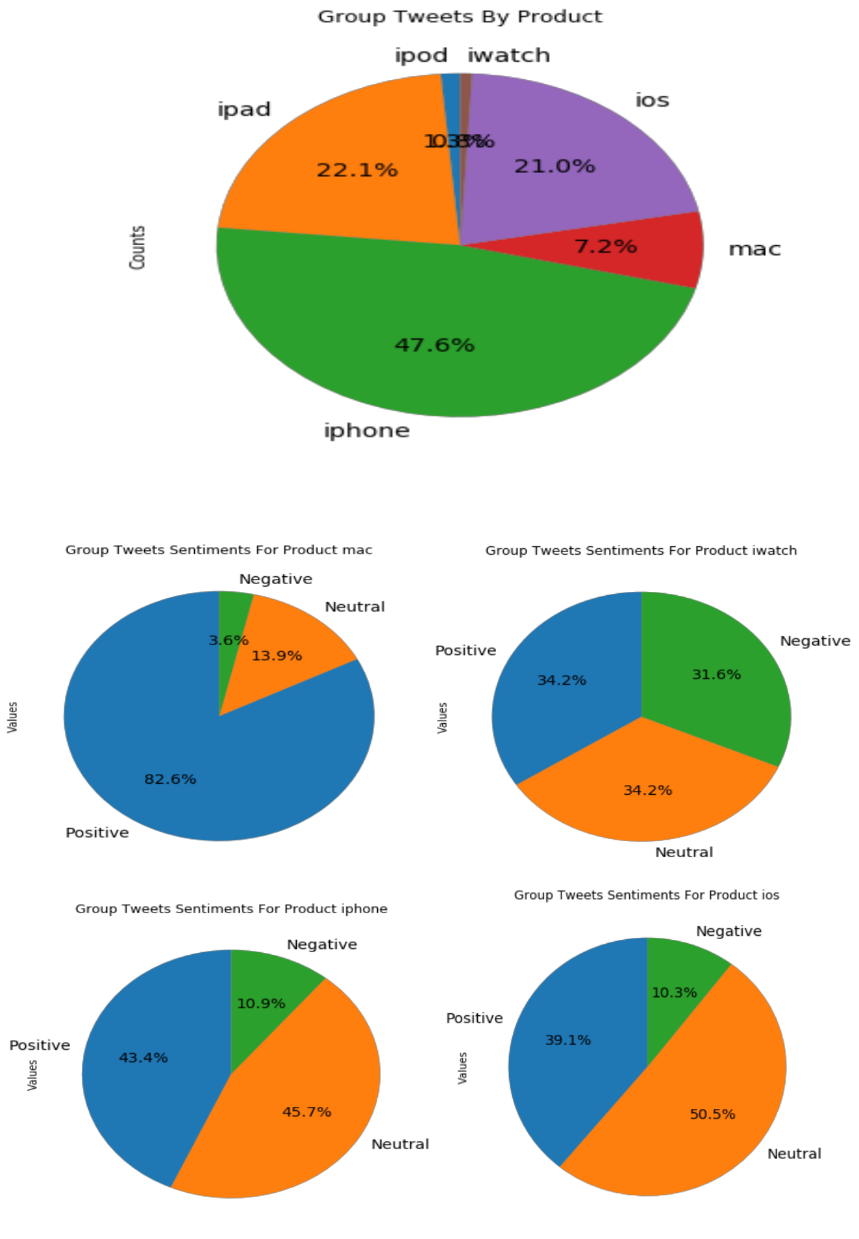
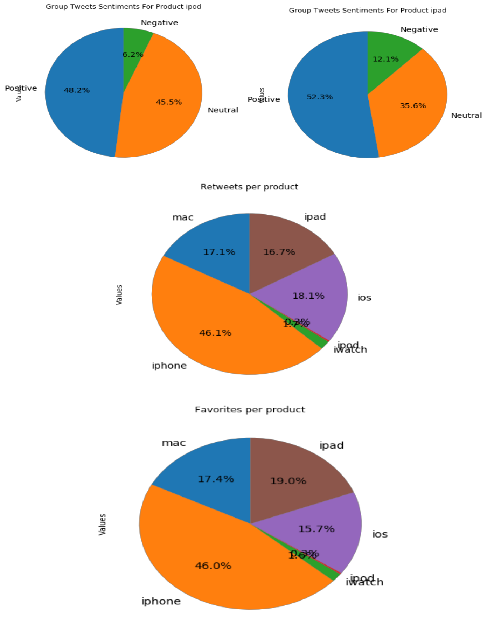

Sentiment Analysis from the Facebook Apple post

R Code-> Code for Compare Apple iPhone X vs OnePlus 6T: Price, Specs, Review

1. #Compare Apple iPhone X vs OnePlus 6T: Price, Specs, Review ...

2. #Try With the search keyword 'Apple X' and 'OnePlus 6T'
3.

4.
5. install.packages('gtrendsR')

6. library (gtrendsR)
7. #define the keywords

8. keywords=c("iPhone X","OnePlus 6T")
9.

10.
11. country=c('US')

12. #set the time window
13. time=("2018-06-01 2018-12-25")

14. #set channels
15. channel='web'

16.
17. trends = gtrends(keywords, gprop =channel,geo=country, time = time )

18. #select only interst over time
19. time_trend=trends$interest_over_time

20. head(time_trend)
21.

22.
23. library(ggplot2)

24.
25. plot<-ggplot(data=time_trend, aes(x=date, y=hits,group=keyword,col=keyword))+

26. geom_line()+xlab('Time')+ylab('Relative Interest')+ theme_bw()+
27. theme(legend.title = element_blank(),legend.position="bottom",legend.text=eleme
nt_text(size=12))+ggtitle("Google Search Volume")

28. plot
29.

30.
31. plot<-ggplot(data=time_trend2, aes(x=date, y=hits,group=keyword,col=keyword))+

32. geom_smooth(span=0.5,se=FALSE)+xlab('Time')+ylab('Relative Interest')+
33. theme_bw()+theme(legend.title = element_blank(),legend.position="bottom",

34. legend.text=element_text(size=12))+ggtitle("Google Search Volume")
35. plot
IN USA
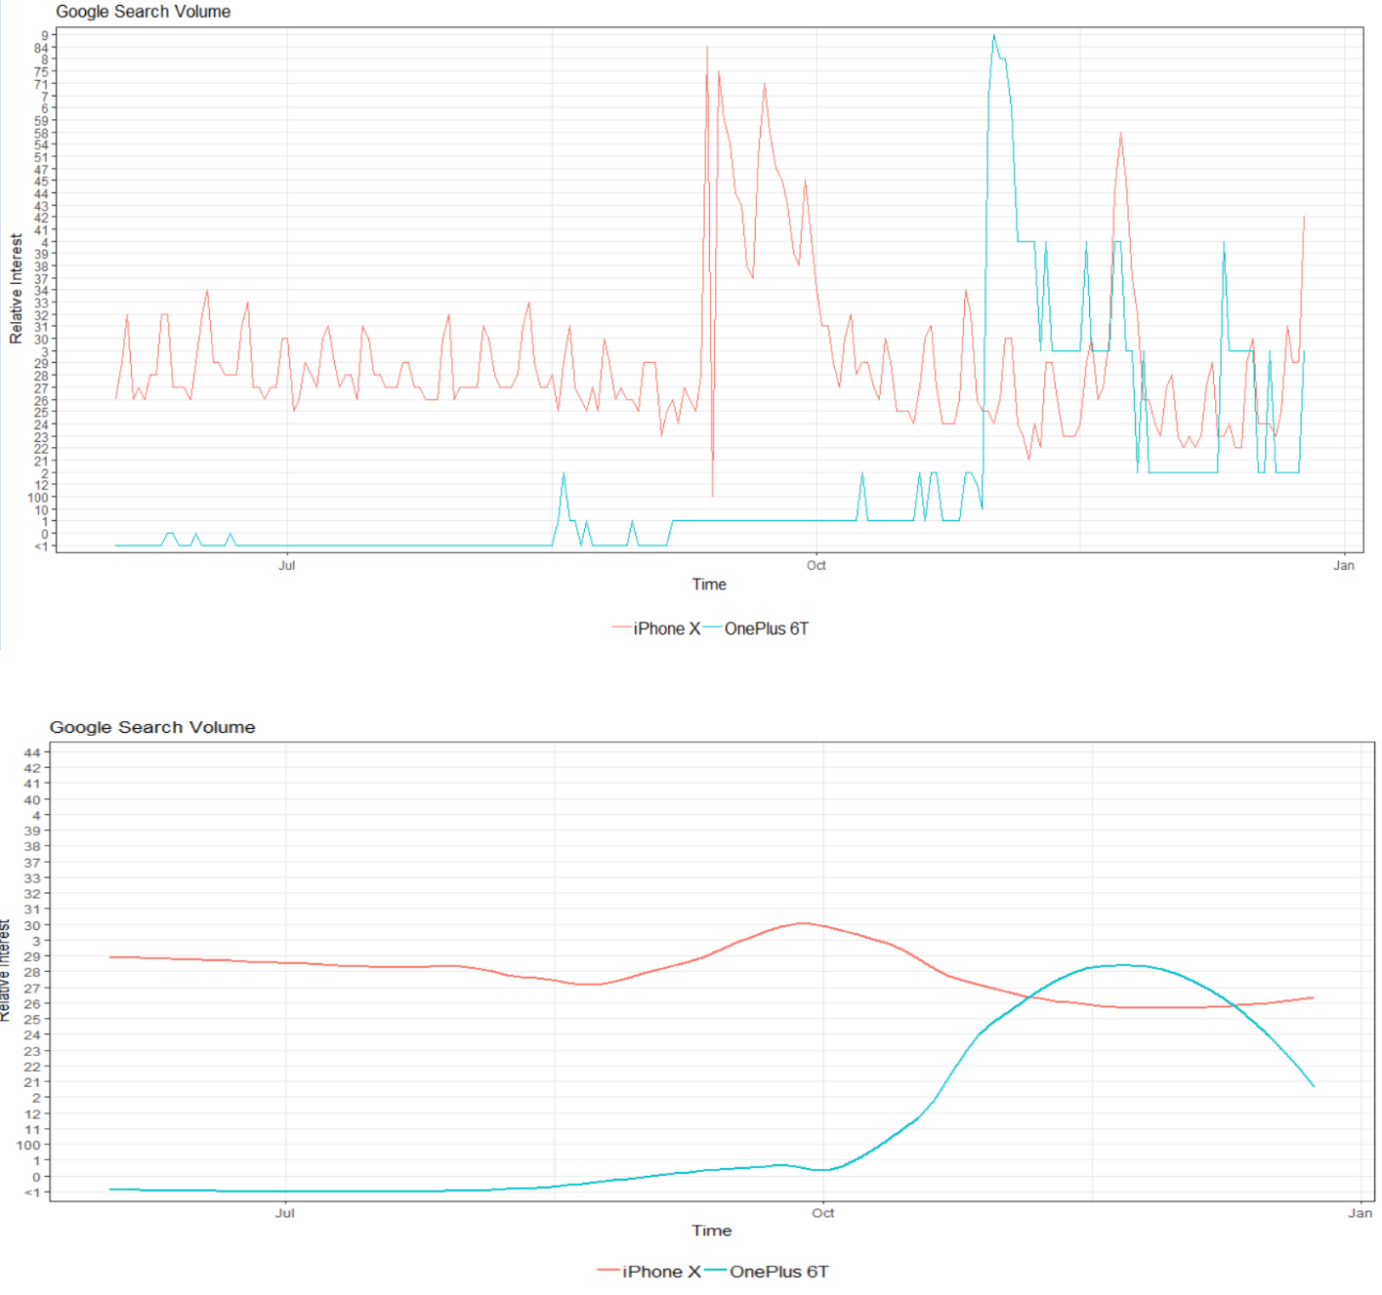

IN China.
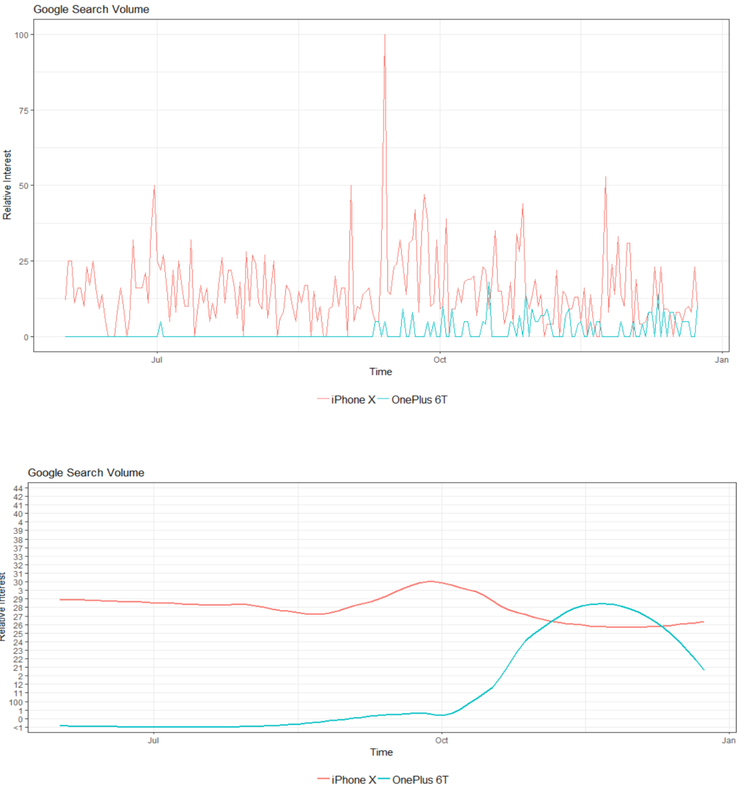

In India.
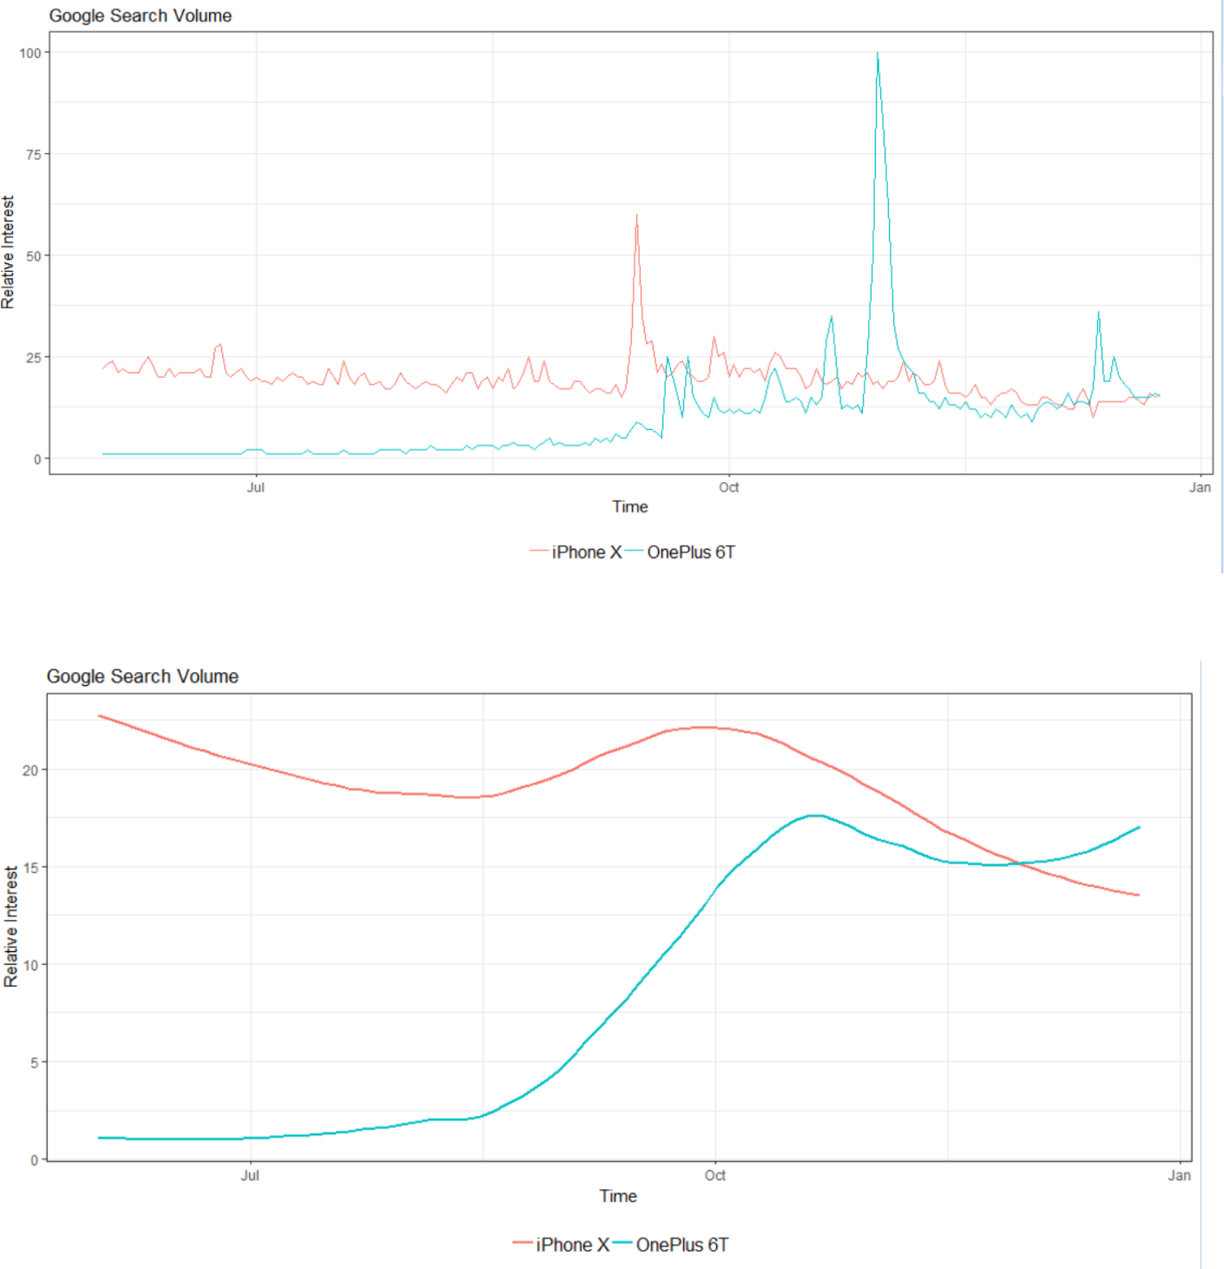
Sentiment analysis Through Facebook.

Graph Version :- 'v3.2’

Access_Token:'EAARHugqHZBwgsaadfaBADEb4d3ULjVP5FHsadfasffitjynxqc7WfoUoZCS4asfasf2ZCFV3B3OS73bXZAL9GE3liAlUbdzosrpjkshdfdjskfhsjkfdskj'
Apple_Page_id = '434174436675167'
post_id = '2216054435308695'

*Constraints: -

1:- | Don’t have access to public post as of now, already sent to Facebook for access review.
2:- | Don’t have google.Cloud API access, it is paid service for access NLP API.

It will generate data like ,

{

"data": [
{
"created_time": "2018-12-12T13:32:51+0000",

"id": "10155659082597610_10155633671607610"
},
{
"message": "Diwali \u26a1\ufe0f\u27282018",
"created_time": "2018-11-08T14:02:01+0000",

"id": "10155659082597610_10155566691542610"
},
{
"message": "Study time \u0040 ISB",
"created_time": "2018-10-07T01:58:35+0000",

"id": "10155659082597610_10155504146587610"
},

{
"created_time": "2018-10-02T04:30:27+0000",
"id": "10155659082597610_10155493231567610"

},

And next step is to collect Comments into .txt file for sentiment analysis.

1. import requests

2. import signal
3. import sys

4.
5. graph_api_version = 'v3.2'

6. access_token = 'EAARHugqHZBwgBADEb4d3ULjVP5FHitjynxqc7WfoUoZCS42ZCFV3B3OS73bXZAL9GE3liA

Dsjfhsdfsdfkjdhsfkhdsfkdhsffioewuroiweruweruewruweprwrkljsfklsjfl;safjasf XF0ZD'
7. # Apple Page ID

8. Apple_Page_id = '434174436675167'
9.

10. # Post Id from where Comments going to extract.
11. post_id = '2216054435308695'

12.

13. url = 'https://graph.facebook.com/{}/{}_{}/comments'.format(graph_api_version, user_id, post_id)
14. comments = []
15.
16. # set limit to 0 to try to download all comments
17. limit = 100

18.

19. def write_comments_to_file(filename):
20. print()

21.
22. if len(comments) == 0:

23. print('No comments to write.')
24. return

25.
26. with open(filename, 'w', encoding='utf-8') as f:

27. for comment in comments:
28. f.write(comment + '\n')

29.
30. print('Wrote {} comments to {}'.format(len(comments), filename))

31.
32.

33. # register a signal handler so that we can exit early
34. def signal_handler(signal, frame):

35. print('KeyboardInterrupt')
36. write_comments_to_file('comments.txt')

37. sys.exit(0)
38.

39. signal.signal(signal.SIGINT, signal_handler)
40.

41. r = requests.get(url, params={'access_token': access_token})
42.

43. while True:
44. data = r.json()

45.
46. # catch errors returned by the Graph API
47. if 'error' in data:
48. raise Exception(data['error']['message'])

49.
50. # append the text of each comment into the comments list

51. for comment in data['data']:
52. # remove line breaks in each comment

53. text = comment['message'].replace('\n', ' ')
54. comments.append(text)

55.
56. print('Got {} comments, total: {}'.format(len(data['data']), len(comments)))

57.
58. # check if we have enough comments

59. if 0 < limit <= len(comments):
60. break
61. # check if there are more comments

62. if 'paging' in data and 'next' in data['paging']:
63. r = requests.get(data['paging']['next'])

64. else:
65. break

66.
67. # save the comments to a file

68. write_comments_to_file('comments.txt')

Now this is the Code where collected comments processed for Sentiments..

1. import signal

2. import sys
3.
4. from google.cloud import language
5. from google.api_core.exceptions import InvalidArgument

6.
7. # create a Google Cloud Natural Languague API Python client

8. | client = language.LanguageServiceClient()
9. # a function which takes a block of text and returns its sentiment and magnitude
10. def detect_sentiment(text):
11. | document = language.types.Document(
12. | content=text,
13. | type=language.enums.Document.Type.PLAIN_TEXT)
14. | sentiment = client.analyze_sentiment(document).document_sentiment
15. | return sentiment.score, sentiment.magnitude
16.
17. count = 0
18. positive_count = 0
19. neutral_count = 0
20. negative_count = 0
21.
22. def print_summary():
23. | print()
24. | print('Total comments analysed: {}'.format(count))
25. | print('Positive : {} ({:.2%})'.format(positive_count, positive_count / count))
26. | print('Negative : {} ({:.2%})'.format(negative_count, negative_count / count))
27. | print('Neutral : {} ({:.2%})'.format(neutral_count, neutral_count / count))
28.
29. | # register a signal handler so that we can exit early
30. def signal_handler(signal, frame):
31. | print('KeyboardInterrupt')
32. | print_summary()
33. | sys.exit(0)
34.
35. signal.signal(signal.SIGINT, signal_handler)
36.
37. | # read our comments.txt file
38. with open('comments.txt', encoding='utf-8') as f:
39. | for line in f:
40. | # use a try-
 | except block since we occasionally get language not supported errors
41. | try:
42. | score, mag = detect_sentiment(line)
43. | except InvalidArgument as e:
44. | # skip the comment if we get an error
45. | print('Skipped 1 comment: ', e.message)
46. | continue
47.
48. | # increment the total count
49. | count += 1
50.
51. | # depending on whether the sentiment is positve, negative or neutral, increment
 | the corresponding count
52. | if score > 0:
53. | positive_count += 1
54. | elif score < 0:
55. | negative_count += 1
56. | else:
57. | neutral_count += 1
58.
59. | # calculate the proportion of comments with each sentiment
60. | positive_proportion = | positive count / count
61. | neutral_proportion = | neutral_count / count

62. negative_proportion = negative_count / count
63.

64. print(
65. 'Count: {}, Positive: {:.3f}, Neutral: {:.3f}, Negative: {:.3f}'.format(

66. count, positive_proportion, neutral_proportion, negative_proportion))
67.

68. print_summary()

samples processed data…
Count: 379, Positive: 0.657, Neutral: 0.190, Negative: 0.153
Count: 380, Positive: 0.655, Neutral: 0.192, Negative: 0.153

Count: 381, Positive: 0.656, Neutral: 0.192, Negative: 0.152
Count: 382, Positive: 0.657, Neutral: 0.191, Negative: 0.152

Count: 383, Positive: 0.658, Neutral: 0.191, Negative: 0.151
Count: 384, Positive: 0.659, Neutral: 0.190, Negative: 0.151

Sentiments Results.

Total comments analyzed: 781
Positive: 530 (67.86%)
Negative: 109 (13.96%)
Neutral : 142 (18.18%)

* End of Code Reports *

